Walk Cranstons Trail Middle Dural - Saturday 23 October
Jennifer Farrer
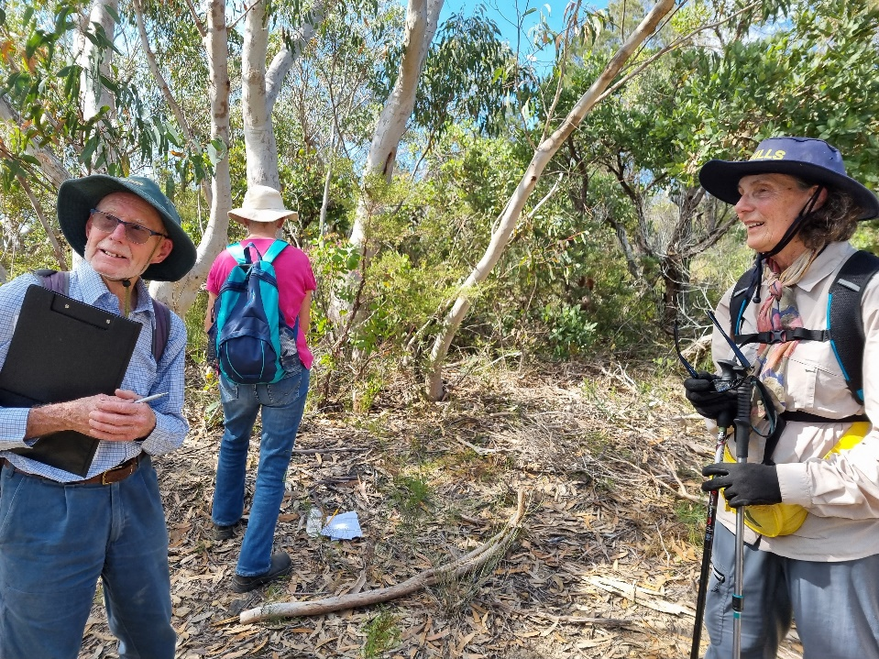
This was our first face-to-face activity after the easing of restrictions. Members were obviously keen to get out and about, as there were 22 of us on the walk.

The Cranstons Trail goes from the end of Cranstons Road Middle Dural to O’Hara’s Creek, a tributary of Cattai Creek. The vegetation is typical of the Hawkesbury sandstone flora. Our group walked the ridgeline to the point where the trail starts to plunge into the valley. In this relatively short distance, the eagle eyes of our members identified 61 species. A full list appears in the Resources section of our website. So, I will just mention some of the highlights:
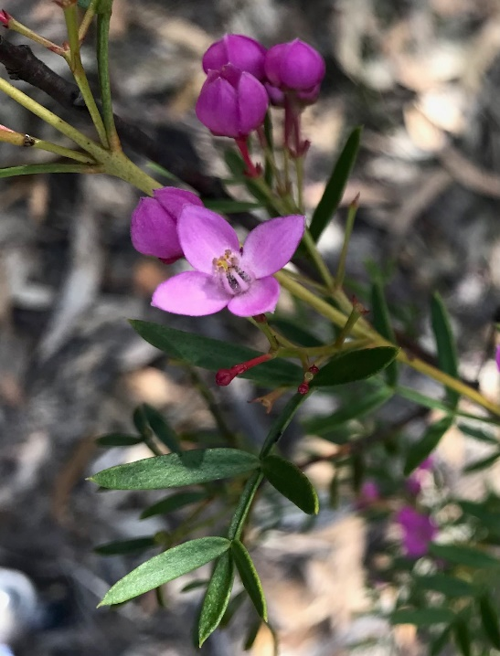
- Several Angophora hispida in bud at the start of the walk. This very scruffy-looking small tree has the most beautiful deep burgundy flower buds. The prominent hairs on the buds and stems give it its name. Hispida means hairy in Latin.
- We saw two plants that were new to most members. A small wattle Acacia hispidula, which was identified by its distinctive seed pods and the hairs on the leaves and stems - there is that Latin word again. Then on the other side of the path the only prostrate Dodonaea in the Sydney region, Dodonaea camfieldii with its prominent seeds.
- Several stands of tall Boronia pinnata.

Boronia pinnata. Photo Lesley Waite

- Clumps of Isopogon anemonifolius all bursting with yellow flowers.
- Many Kunzea capitata plants with their distinctive terminal pink flowers. There were also many bushes of the more common Kunzea ambigua in flower.
- Philotheca buxifolia in flower. This is not seen in many places locally.
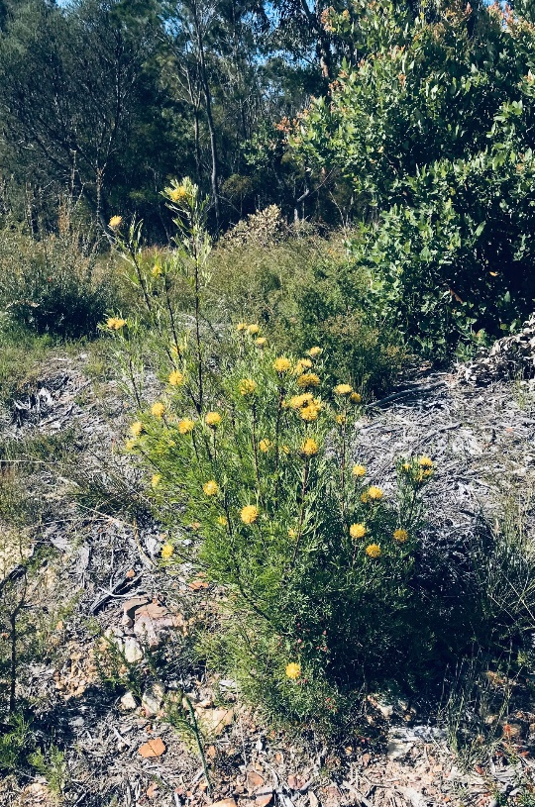
- One sighting of the rare Darwinia biflora. Rare because it only occurs in parts of north and north-west Sydney.

This was our last walk for this year. We will be out again next year when the summer is over.

Isopogon anemonifolius. Photo Lesley Waite

